CHAPTER FIFTEEN

MONSOONS
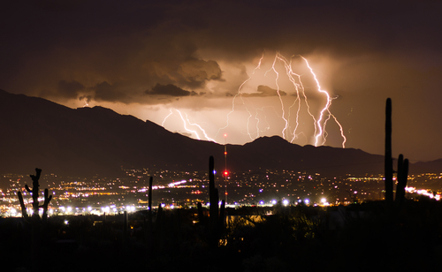
Monsoons, a hot weather phenomenon of stupendous thunderstorms, is a time of trembling dogs hiding in closets – or maybe just cowering by your comforting knees. They hate that ear-pounding, floor-vibrating noise. We once had a peach of a friendly golden retriever who tried to escape the booming by hiding under cars. RIP dear doggie Pandora. Once a tow truck had to be called to raise the car to get her back home.
It’s the season of rushing waters scouring dusty arroyos, runoff waters that leap from banks and cover low bits of roadways. Terrifying in their violence, sometimes that outflow swallows cars, and you’d best not be in one. It’s a time of hope and excitement for this parched place, a time when electricity charges the atmosphere with zippy negative ions. Those ions stimulate cilia in your ears and nose, making you feel perky and happy. Did you know that?
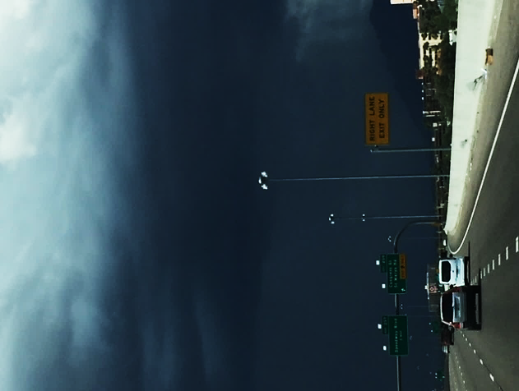
When I was little and dark clouds rolled in, cool downdrafts brushed our cheeks as we youngsters ran jumping for joy in the first fat sprinkles, sticking out our tongues to catch a drop. We joyfully whooped and jumped, bounding around like baby lambs till our mothers scooped us up and dragged us inside. Ah, childhood. Now we stay in and watch the show through the windows.
Monsoons have their own season? Yes, Tucson has five seasons, not four. Fall, winter, spring, summer – and monsoon. Five. I have that on authority.
People hoping to escape the storm.

Apps are made for your cellphone whose notifications are whimsical rumbles, warnings if any storm action is in the offing. Also, the app will notify you of nearby lightning - or even to tell you that you need to scramble for high ground, if you’re in flood zones. We are reminded that floods can happen way downstream from the deluge; around dry Tucson, water rolls off the mountains.
NOAA also patches in texts of alarm for high wind gusts and hail, naming places to avoid. You can get maps of lightning strikes, cloud cover, and distance from the nearest display.
“Quick! Grab a chair Maudie!”
You settle yourself on the patio to watch the light show, cloud to ground bolts splitting the black sky. And you stay on the qui vive to high-tail it indoors when the forecast proves right.
No garage? Well blanket up your car, do your best to avoid hail damage. Nature’s showtime can extract a tiresome price.
The deluge comes. If you’re lucky, the barrage can be wild and wonderfully overwhelming. Puddles turn to pools, pool surfaces dance with the downpour, snakes slither out of flooded holes and seek high ground, usually draping themselves over your sun-heated driveway. Watch out.
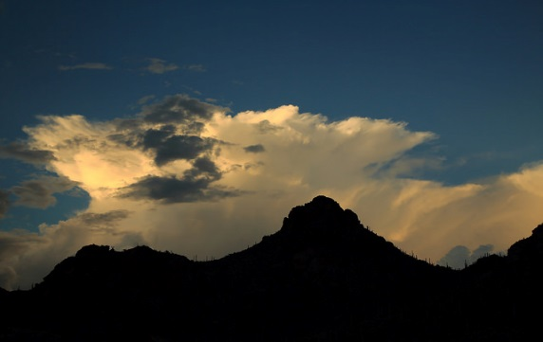
The afternoon’s oven-hot air that drove birds to find shade under patio chairs, that nice spa temp for the cold-blooded snake, has now climbed aloft and cooled at condensation levels. Clouds have bloomed and become towering rain factories, firing off decibels of radar returns from their busy cores. You can hear it happening. Aircraft beware.
This Photo by Unknown Author is licensed under CC BY
Earlier, you watched as buildups rose. Little white puffs began to peek suggestively over distant ridges. Then you saw them pooch out and billow up. They continued rising, reaching high over peaks. They spilled over, crept toward you, escalating to fanciful cloud towers. That dazzling white suddenly morphed to threatening gray, slate floors for castellating turrets, the odd thick veil of rainfall sweeping out below. Were they coming your way?
Looks like it, doesn’t it? That app could have told you. The air is split by a ripping bolt, and the dog heads for the closet.
Grab a chair and enjoy the show.

